1. Routing:

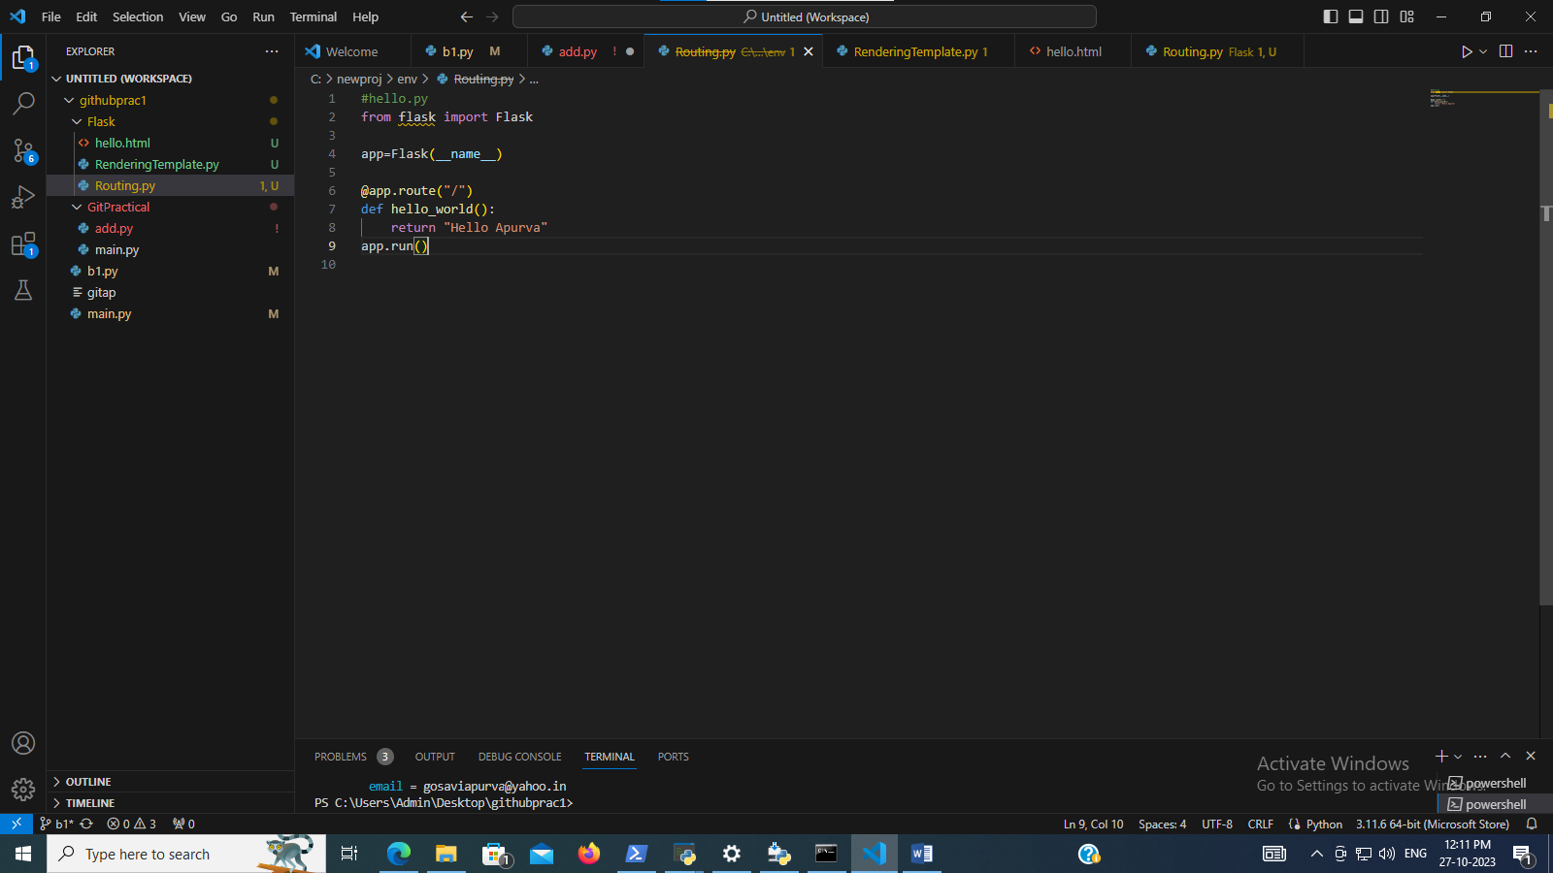

#hello.py

from flask import Flask

app=Flask(__name__)

@app.route("/")

def hello_world():

    return "Hello Apurva"

app.run()

1. Rendering template:

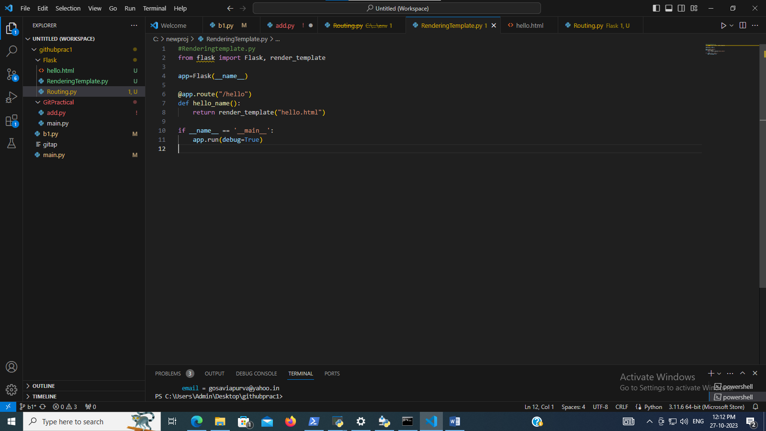

#Renderingtemplate.py

from flask import Flask, render_template

app=Flask(__name__)

@app.route("/hello")

def hello_name():

    return render_template("hello.html")

if __name__ == '__main__':

    app.run(debug=True)

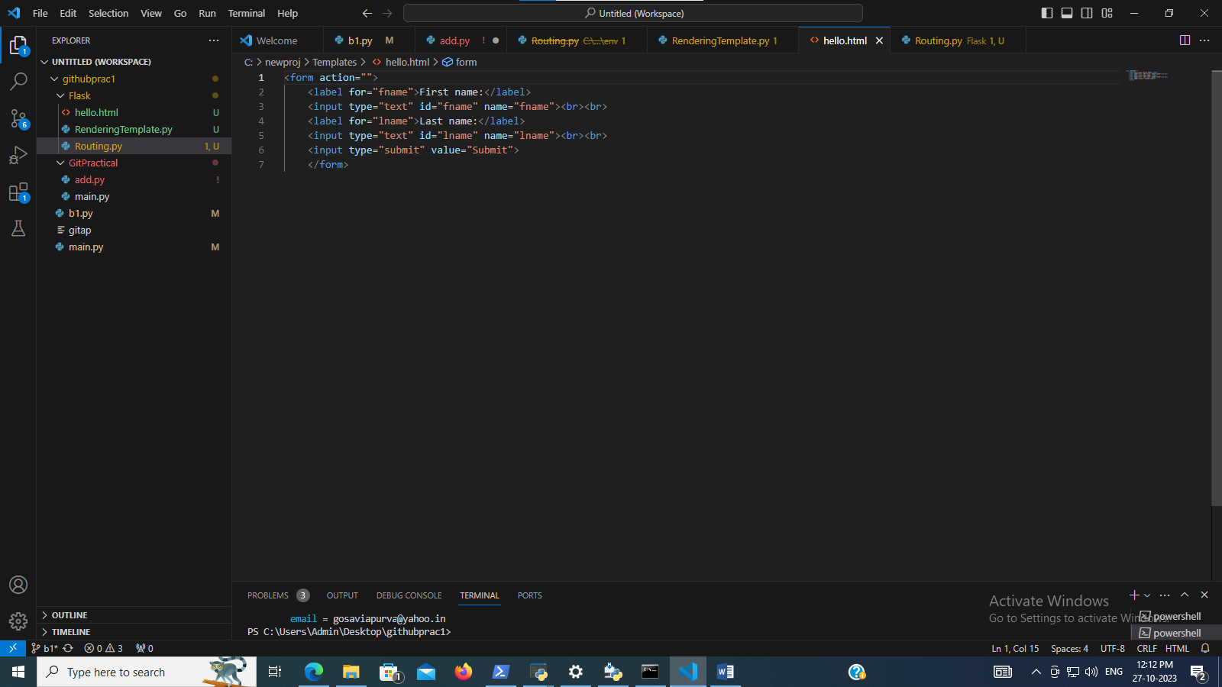

<form action="">

    <label for="fname">First name:</label>

    <input type="text" id="fname" name="fname"><br><br>

    <label for="lname">Last name:</label>

    <input type="text" id="lname" name="lname"><br><br>

    <input type="submit" value="Submit">

    </form>

File locations:

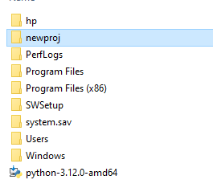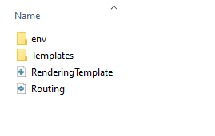

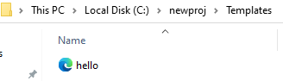

Run file http🡪 add “\hello” in the URL (html file name)

Output:

